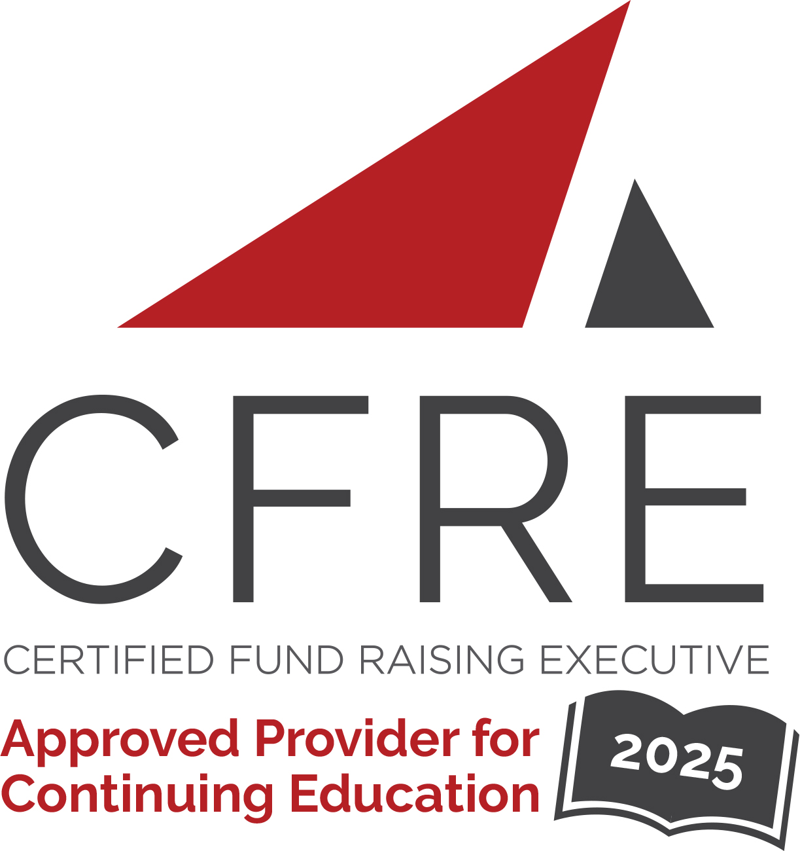  CFRE International has developed this form as a way for you to quickly track (and keep in your files!) the continuing education sessions you have attended. Simply check the boxes next to the sessions you attended. At the end of the conference, add up the total number of hours. Keep this sheet and you will be ready to complete your application form. All of the session slots listed are eligible for continuing education points on your CFRE application for initial certification and/or recertification. Sessions not listed here are not eligible for points. |  | CONTINUING EDUCATION POINTS TRACKER

Activity Organizer: - NEAHP
Title of Activity: - 2025 NEAHP Annual Educational Conference
Names of Presenter(s): - Various
Dates and Location: - 3-5 March, 2025 – Hyannis, MA USA

Date: 3 March, 2025
Session 8:00am – 4:00pm (7 pts)
- AHP Primer

Date: 3 March, 2025
Session 2: 12:00pm – 4:00pm (4 pts)
- Asking Workshop

Date: 4 March, 2025
Session 3: 9:00am – 10:00am (1 pt)
- Keynote: Empowering Change: A Philanthropic Journey to Maternal Health Equity

Date: 4 March, 2025
Session 4: 10:45am – 12:00pm (1.25 pts)
- AI: From Basics to Practical Tips and Shared Insights
- Dynamic Dialogues: The Importance of Physician Giving in Nonprofit Healthcare
- Preserving Your Community Healthcare Identity with a Larger System
- The Color of Care: Understanding Racial Disparities in Maternal Health Outcomes

Date: 4 March, 2025
Session 5: 2:00pm – 3:15pm (1.25 pts)
- Adult Learning in Fundraising: How to Teach a Generous Disposition
- Dynamic Dialogues: The Pros and Cons of Pre-Campaign Studies
- inspiring More (and Bigger) Major and Principal Gifts
- Leading in Complexity: Navigating Challenges and Driving Innovation in Healthcare Philanthropy

Date: 4 March, 2025
Session 5: 3:45pm – 5:00pm (1.25 pts)
- Dynamic Dialogues: Building Strong Remote Teams
- How to Have a Planned Giving Program Without a Planned Giving Officer
- Unlocking the Power of Your Board: Maximize Impact, Ignite Engagement, and Elevate Potential
- Using Naming Opportunities to Achieve Fundraising Success

Date: 5 March, 2025
Session 6: 8:30am – 9:15am (1 pt)
- Keynote: Shaping the Future of Healthcare: Insights and Innovation in Philanthropy

Date: 5 March, 2025
Session 7: 10:00am – 11:00am (1 pt)
- Building a Hub and Spoke Development Operation: Standardizing Operations and Maintaining Authenticity
- Dynamic Dialogues: Building Strong Development Teams Through Experiential Learning
- Philanthropy is Reshaping the Landscape of Mental Health Care
- The Journey from Transactional to Trusting Relationships

Date: 4 March, 2025
Session 4: 11:15am – 12:15pm (1 pt)
- Donor Engagement: The Power of Peer to Peer Fundraising
- Donor Recognition Tracking in Raiser’s Edge NXT Database
- Dynamic Dialogues: Running on All Cylinders (Small Shop Fundraising)
- Healing with Heart: The Power of Gratitude in Healthcare Philanthropy

Date: 4 March, 2025
Session 4: 12:15pm – 1:30pm (1.25 pts)
- Lunch & Closing Keynote: Building Bridges, Not Barriers: The Power of Trust-Based Philanthropy

Total number of points attained: __________

