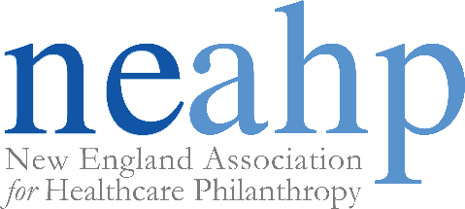

2026 Scott C. Fithan SCHOLARSHIP
The New England Association for Healthcare Philanthropy (NEAHP) is pleased to offer the Scott C. Fithian Scholarship for the 2026 NEAHP Annual Educational Conference, which will take place on March 2-4, 2026 at the Westin Harborview in Portland, ME and will cover the cost of your conference registration and hotel fees.
About Scott C. Fithian
Scott was a valued member of NEAHP who passed away at the young age of 45 after an extended battle with pancreatic cancer. Scott was widely considered a pioneer in the financial services industry through his ground breaking work in the area of client-centered planning. As founder and CEO of The Legacy Companies, Scott’s values-based methodology has inspired thousands of Advisors and their clients to approach their planning in a different, more meaningful way. He was a recognized speaker and trainer of professional advisors residing throughout the U.S and Canada. He was known nationally for having developed several significant contributions that dramatically impacted the Financial Services industry. He also had a tremendous impact on NEAHP by insisting that resource providers play a stronger role in the organization. As a result, NEAHP has never been more viable. For all these reasons and many more, we honor Scott through this scholarship.
To apply for a chance to experience the 2026 NEAHP Educational Conference, please complete the attached application and return to leeann.moore@mchmail.org no later than Friday, January 16, 2026 by 4 p.m.
In addition to your application, please submit a one-page statement detailing your fundraising experience, the reasons you wish to attend the conference, and why you feel you are the best candidate to receive the scholarship.
Rules and Conditions
- Applications will not be accepted that are incomplete or do not have the one-page essay addressing the items outlined above.
- Candidates must be active members of NEAHP at the time of application.
- The scholarship covers the conference registration and hotel fees only. Recipients will be responsible for travel and other incidentals.
- The NEAHP Scott C. Fithian Scholarship recipient will be recognized at the annual conference.
The Scholarship Committee will review all applications and notify the winner no later than Monday, January 26, 2026.
Any questions, please contact LeeAnn Moore at LeeAnn.Moore@mchmail.org.
NEAHP 2026 Scott C. Fithian SCHOLARSHIP APPLICATION FORM

Applicant’s Name:
Applicant’s Title:
Institution:
Address:
Phone: | ( ) - |  |  |  |  |  |  | Fax: | ( ) -
Total Years of Fund Raising Experience: |  |  |  |  |  |  |  | Healthcare: |  |  | Other:
Total # of Staff in Dept./Fnd: |  |  |  |  |  |  | Age of Fundraising Program: |  |  |  |  | years

If you have participated on any NEAHP committees or held any NEAHP leadership positions, please list:

Applicant’s Signature: |  |  |  | Date:
Supervisor’s Name:
Supervisor’s Signature:

(Please attach your one-page statement summarizing the history of your fundraising experience, reasons you are requesting the scholarship award, and reasons you believe you are deserving of this award.)

Applications must be received by Friday, January 16, 2026 by 4 pm.

Please submit your application to LeeAnn Moore at LeeAnn.Moore@mchmail.org

